Make the keyboard not come up.

Also, make the Bio-Care Icon Bigger

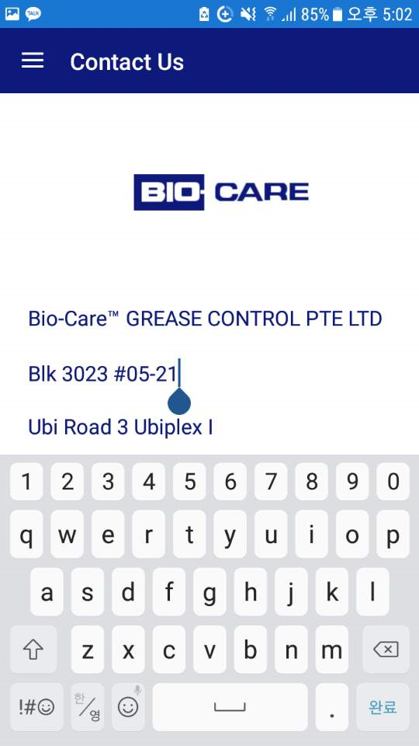

**Rep: Have corrected it. Please check**

Replace “Are you sure about stopping work?” to **“Are you sure you want to stop work?”**

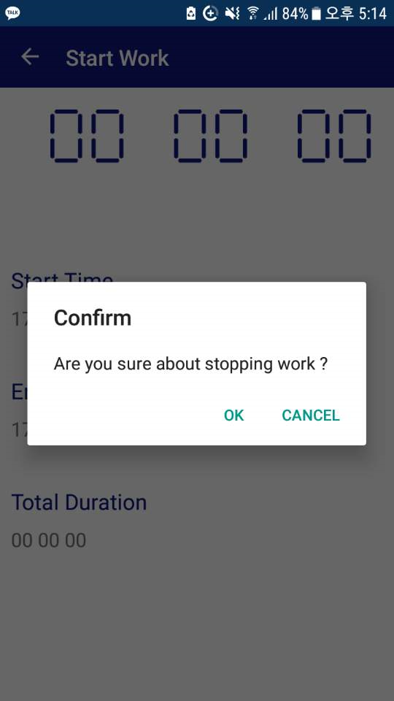

**Rep: Have corrected it. Please check**

**For Forgot Password Page**

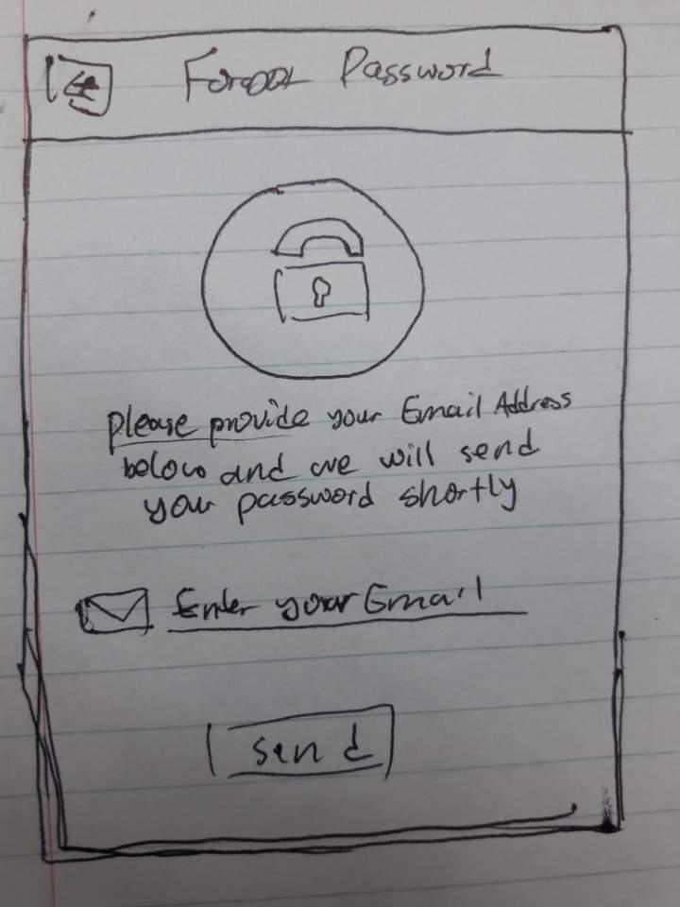

Include the icon at the top center of the screen like the photo shown above. And have the text” Please provide your Email Address below and we will send your password shortly” at the center and follow the center format. Something exactly like this: 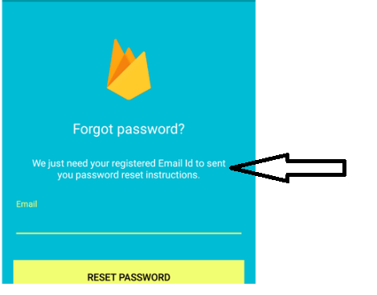

Use this Icon:



**Rep: Have corrected it. Please check**

Replace “Your Feedback Successfully Submitted” to **“Your feedback has been successfully submitted”**

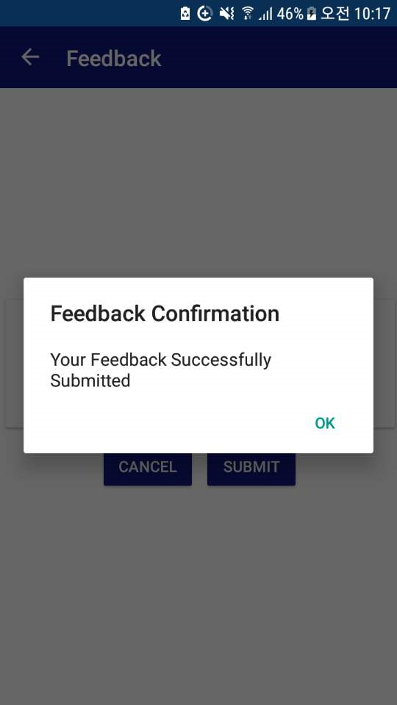

**Rep: Have corrected it. Please check**

**For Reminders Page**

When the user presses confirm after editing the Reminders Details Page it leads to this page:

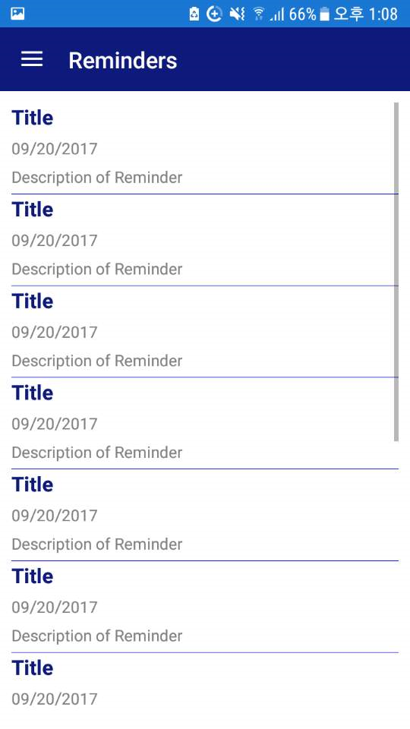

When user presses confirm after editing the Reminders Details Page it should lead to the same Reminders Details Page that was going to be edited with the saved state(I understand the saving will be done during the integration).

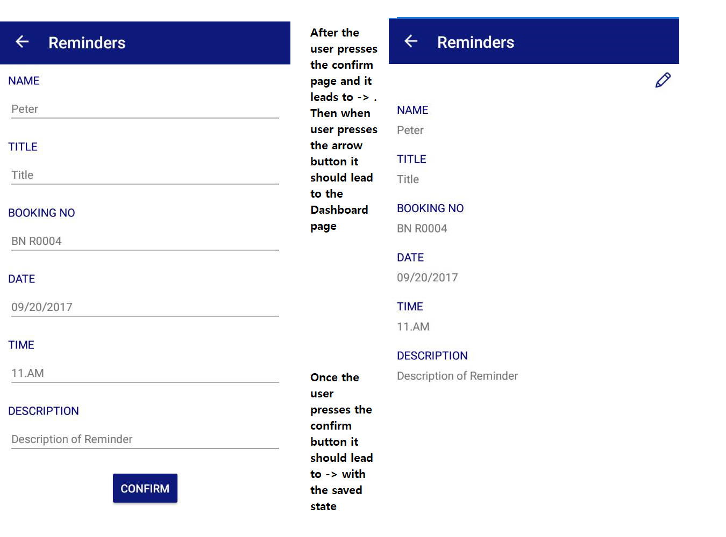

Rep: Now I it leads to the previous page. I have informed gowtham regarding this. He said once we go for server integration we will implement this with saved one.

**For Start Work Page**

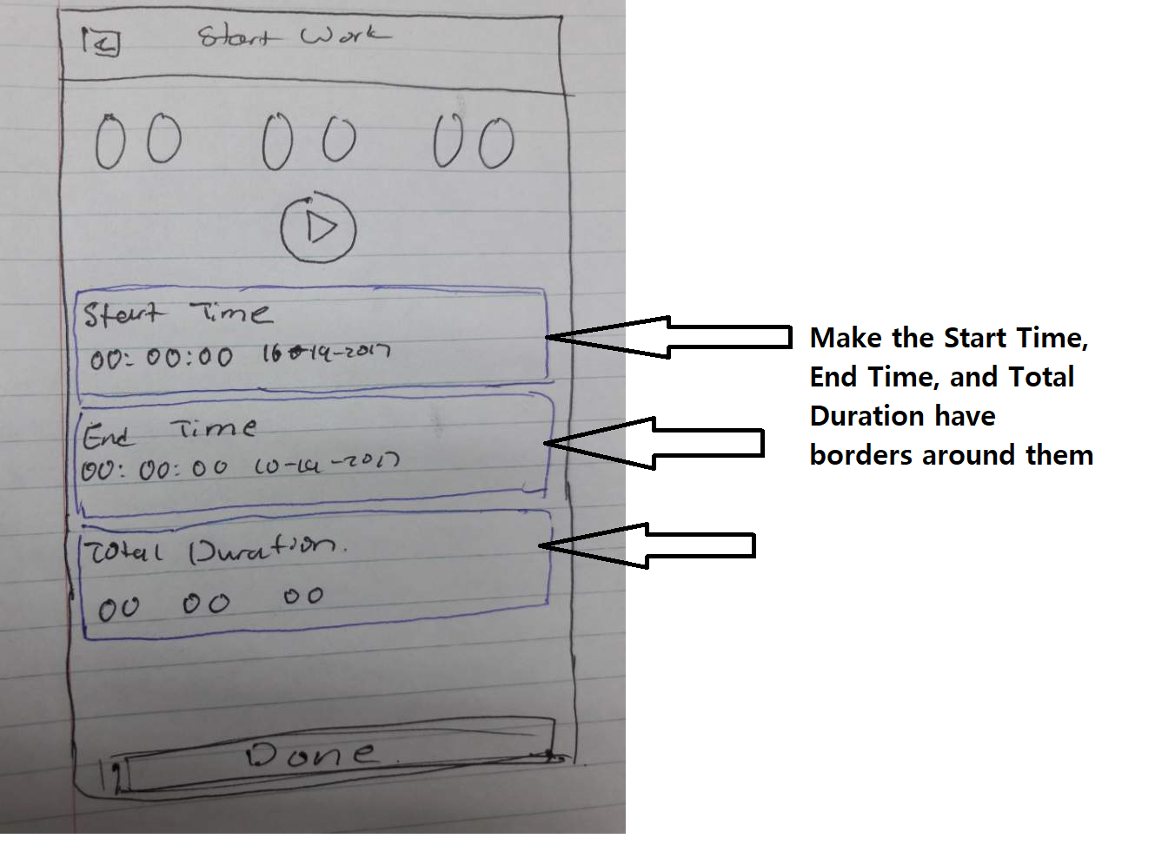

**Rep: Have corrected it. Please check**